**Adopting a Person-centred Approach to Supervision** - Workbook

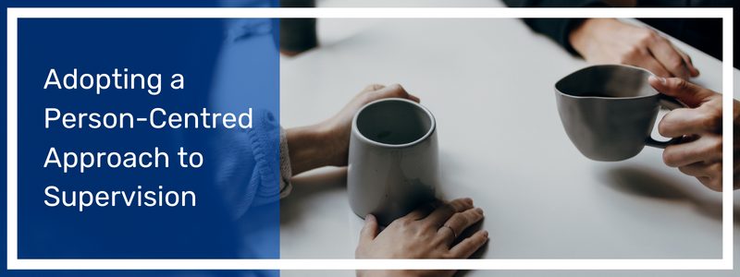

Contents

**Module 1 – Person-Centred Reflective Supervision** 2

**Module 2** - **Values and Beliefs** 6

**Module 3- Adopting a Person Centred Approach** ……………………………………………………………………………8

**Module 4 - When Supervision Works** 11

**Module 5 - The Power of Reflection in Supervision** 15

**Module 6: Communication Skills** 19

**Module 7 - The Role of Power Dynamics in Supervision** 24

**Module 8 - Trauma Informed Supervision** 28

**Module 9 - Choosing the Right Model of Supervision for you** 33

**Module 10 - Knowing and Setting Our Boundaries as Supervisors** 40

**When in Doubt, Refer Out (Signposting)** 44

**Bringing it all Together** 46

Authored by Lynn Collins (lynn.collins2@nhs.net) and Alice Stewardson (alice.stewardson@nhs.net) while under employment at Sussex NHS ICB. Last updated October 2024.

# **Module 1** – **Person – Centred reflective Supervision – An introduction.**

**Video Transcript:**

"*Welcome to a person-centred approach to Supervision. We are pleased you have chosen to explore the essence of this approach and enhance your understanding of person-centredness within the context of healthcare supervision.*

*Person-centeredness is an approach that values and prioritises individuals' unique needs, preferences, and experiences. When applied to supervision, it means recognising and embracing the individuality and autonomy of the person and tailoring the supervisory process to their specific needs ( Mccormack B et al 2015)*

*This program has been created for all professionals across health and social care focusing on supervisors who want to foster supportive and empowering supervisory relationships, ultimately making a difference by taking a person–centred approach. This program enables you to pick and mix modules tailored to your interests; you can work through your chosen module at your own pace. We recommend that you take the opportunity to reflect on points throughout each section;*[***a forum***](https://oneworkforcesussex.com/mod/forum/view.php?id=366)*is available to share your ideas if you wish."*

**By the end of module 1, you will have:**  
  
Gained an understanding of person-centeredness and consider ways to apply this approach to your clinical supervision practice.

You will have explored the principles and core elements of person-centredness within supervision and examine the importance of understanding and respecting individuals’ perspectives, needs, and aspirations.

**Reflective Question: What does the word 'supervision' mean to you?**

|  |
| --- |
| *Use this space to write your answer, and then copy and paste into your browser window.* |

Answer in as many or few words as you wish. Think about:

* If the definition of supervision changed for you over your career?
* What supervision means to you now in your current role

**What is this thing called Supervision?**

There is not a single definition for supervision, but these are some suggestions:

* ‘’Clinical supervision establishes a formal process of support, reflection, learning, and development that benefits both newly registered and experienced health professionals by supporting their individual development’’. (NHS Employers 2023)
* "Clinical supervision is a process of professional support, reflection, and learning that contributes to an individual’s personal and professional development" (Butterworth 2022)
* “Clinical supervision can help staff to manage the personal and professional demands created by the nature of their work.’’ (RCN 2021)

**Reflective Question:** **Why does Clinical Supervision matter?**

|  |
| --- |
| *Use this space to write your answer, and then copy and paste into your browser window.* |

Think about:

* Why supervision matters to your team?
* What has it meant for your professional development?
* What the benefits of supervision can be?

Once again, there is not a single answer to why clinical supervision matters, but these are some of the benefits:

* Support,
* impacting on CPD,
* Improves wellbeing and job satisfaction,
* Improves work environment and culture,
* Impacts directly of quality of care,
* A safe space for reflection and to feel valued,
* Opportunity for feedback/feedforward.

**The Role of Being a Supervisor**

The supervisor actively facilitates reflection, offers guidance, and provides appropriate support.

**Reflective Question: In your experience, what have you found to be the most important elements of the clinical supervision role and why?**

|  |
| --- |
| *Use this space to write your answer, and then copy and paste into your browser window.* |

Answer in as many or few words as you wish. Think about:

* The key elements of clinical supervision

**Who are you as a Supervisor?**

This is a time to consider what are the enablers and barriers to providing supervision for you within your workplace. Your own supervision experience can impact your approach as a supervisor.

The questions in the circles can guide your reflection, on areas like your approach and supervisory style, and think about how you could be an even better supervisor.

**Activity:** Set a timer for 5 minutes and reflect on your strengths in relation to the questions in the circle.

**Reflective Question: What would you like more of in your supervision and why? *How are you going to make this happen?***

|  |
| --- |
| *Use this space to write your answer, and then copy and paste into your browser window.* |

**Reflective Question:** **What would you like less of in your supervision? *What do you need to do to make this happen?***

|  |
| --- |
| *Use this space to write your answer, and then copy and paste into your browser window.* |

**References:**

* McCormack, B., Borg, M., Cardiff, S., Dewing, J., Jacobs, G., Janes, N., Karlsson, B., McCance, T., Mekki, T.E., Porock, D. and Van Lieshout, F., 2015. Person-centredness-the'state'of the art. Available at [IPDJ_05(suppl)_01.pdf (fons.org)](https://www.fons.org/Resources/Documents/Journal/Vol5Suppl/IPDJ_05(suppl)_01.pdf)
* NHS Employees 2023 available at: [Clinical supervision models for registered professionals | NHS Employers](https://www.nhsemployers.org/articles/clinical-supervision-models-registered-professionals)
* "Clinical supervision can help staff to manage the personal and professional demands created by the nature of their work.’’ RCN 2021 [Clinical supervision by other professionals debate | Royal College of Nursing (rcn.org.uk)](https://www.rcn.org.uk/congress/congress-events/4-clinical-supervision-by-other-professional)

# **Module 2** - [**Values and Beliefs**](https://oneworkforcesussex.com/mod/hvp/view.php?id=350)

We all live our daily lives by a set of values that sit within deep-seated beliefs that we may or may not be aware of that shape our behaviours. Our childhood, families, backgrounds, cultures, religions, and relationships have formed values and beliefs about how people should behave.

Values are also supported by a set of unwritten rules or norms about what is socially acceptable behaviour both personally and within society.

**Values and Beliefs Activity:**

We invite you to explore this activity *(Mccormack, Mccane & Dewing)* to take a deeper dive into who you are, this is a great activity to explore not just functional aspects of our lives, such as our job, relationships, career prospects that usually come to mind when asking who we are. By thinking about the following questions can help us focus on our core being.

**Activity: Set a 10 minute timer and quickly write down answers to these questions.**

**ME**

|  |
| --- |
| *Jot down your answers in this box* |

Reflect on your answers to these questions.

* Are there any surprises?
* Have you gain new insights about yourself as a person?
* What do your collective responses tell you about who you are?

This activity helps us think about our ‘being in the world’ and what is important over time and if you revisit at a later stage can show how you are evolving as a person. You can also share this activity with your supervisee to support a greater understanding of each other.

**Exploring your Beliefs and Practice:**

**Activity - 10 minute Reflection**

Take a blank page (or use the box below) and brainstorm your beliefs and values in relation to:

**Should euthanasia be legal?**

* Why or why not?
* Do you feel strongly about this?
* What do you think influences your views on this?

|  |
| --- |
| *Use this space to jot down your answer* |

Values are based on what is important as well as how important they are to you.  This means you have internalised values that guide your understanding of the world around you, directing and justifying your actions, sustaining your attitudes, and inevitably judging others. Values can be abstract, such as freedom of choice, or explicitly relating to, for example, hunger, poverty, racism.

* If you would like to take a closer look at beliefs and values please click on the link below and download the activity (PDF Download): [**Living Into Our Values - Brené Brown**](https://oneworkforcesussex.com/mod/resource/view.php?id=351)
* And access this other useful tool for defining your values: [**What Are Your Values? - Deciding What's Important in Life (mindtools.com)**](https://www.mindtools.com/a5eygum/what-are-your-values)

**References:**

* [Living Into Our Values - Brené Brown (brenebrown.com)](https://brenebrown.com/resources/living-into-our-values/)
* [What Are Your Values? - Deciding What's Important in Life (mindtools.com)](https://www.mindtools.com/a5eygum/what-are-your-values)

# **Module 3 – Adopting a Person Centred Approach**

**What is person-centredness? (Video Transcript)**

*"Person-centredness is established through forming and fostering a therapeutic relationship between persons, in this case, a supervisor and supervisee. Values of respect, understanding, and individual rights to self-determination underpin this approach. Cultures of empowerment enable person-centredness and foster a continuous approach to professional development (McCormack & McCance, 2017)*

*Research suggests that people who adopt a person-centred approach are more satisfied in their jobs and feel more competent and accomplished (Willemse et al 2014), which directly impacts retention (Ho et al 2021). Through reflective practice, discussing the impact of work on a person within supervision can strengthen the belief in handling difficulties and challenges faced; reflection is essential in creating new understanding and knowledge (Christianne E. Nordbøe1*, Ingela Enmarker Clinical supervision: A mechanism to support person-centred practice? An integrative review of the literature).*

*Person-centeredness is a philosophical and ethical approach that places the individual at the centre of their own supervision, valuing their autonomy, preferences, and experiences. It encompasses several vital characteristics that guide the provision of person-centeredness within a supervisory setting."*

**Essential characteristics of person-centeredness:**

* **An Individualised Approach:** Person-centeredness recognizes and respects that each person is unique with their own set of needs, values, preferences, and goals. It emphasizes tailoring support to meet the specific requirements and desires of the individual, rather than using a standardized or one-size-fits-all approach.
* **Collaboration:** Person-centeredness promotes an active partnership between the supervisee and supervisor encouraging shared decision-making that considers the Supervisee’s values, goals, and preferences. This collaboration fosters a sense of control, empowerment, and ownership over one's own support.
* **Respect for Autonomy and Dignity:** Person-centeredness upholds the principle of autonomy, respecting and supporting individuals' rights to make choices and decisions about their own lives. It values their dignity and treats them respectfully, recognizing their inherent worth, beliefs, and cultural or personal identities.
* **Holistic Perspective:** Person-centeredness considers the whole person, considering their physical, emotional, spiritual, and social well-being. It acknowledges the interconnectedness of different aspects of a person's life and recognizes the importance of addressing all relevant dimensions to promote overall well-being.
* **Empathy and Compassion:** Person-centeredness emphasizes the importance of empathy and compassion in supporting others. It requires others to seek to understand and empathize with the individual's perspective, emotions, and experiences, fostering a trusting and therapeutic relationship.
* **Flexibility and Adaptability:** Person-centeredness recognizes that needs, preferences, and circumstances can change over time. It encourages flexibility and adaptability in its approach, adjusting support as necessary to meet evolving needs and goals.
* **Feedback and Evaluation:** Person-centeredness values feedback from the supervisee seeking their input and actively listening to their suggestions, concerns, and experiences. It involves ongoing evaluation and reflection to improve the quality and effectiveness of the person-centred approach continuously.

By embodying these characteristics, person-centeredness fosters a supportive, empowering, and respectful environment that promotes the supervisee and supervisor's well-being, autonomy, and satisfaction.

**Applying person-centredness:**

**Reflective Question: Can you think of a time when you have experienced person-centredness, what did this look like for you?** *This could be an example from your professional or personal life, it could be person-centredness you have experienced from a friend or family member.*

|  |
| --- |
| *Use this space to write your answer, and then copy and paste into your browser window.* |

**Reflective Question: What did this feel like?**

|  |
| --- |
| *Use this space to write your answer, and then copy and paste into your browser window.* |

**Reflective Question: Thinking about your earlier reflection how could you translate your experiences into supporting your supervisee?**

|  |
| --- |
| *Use this space to write your answer, and then copy and paste into your browser window.* |

As a supervisor, what can you do to bring a person–centred approach to your supervision practice?

|  |
| --- |
| *Use this space to write your answer, and then copy and paste into your browser window.* |

**Final reflection:** Has anything in this module challenged your thoughts about person-centredness?

|  |
| --- |
| *Use this space to write your answer.* |

**References:**

* McCance, T. and McCormack, B., 2017. The person-centred practice framework. Person-centred practice in nursing and health care: Theory and practice, pp.36-64.
* Ho, P., Cheong, R.C.Y., Ong, S.P., Fusek, C., Wee, S.L. and Yap, P.L.K., 2021. Person-centred care transformation in a nursing home for residents with dementia. Dementia and Geriatric Cognitive Disorders Extra, 11(1), pp.1-9.

# **Module 4 -** [**When Supervision Works**](https://oneworkforcesussex.com/mod/hvp/view.php?id=354)

**When Supervision Works - Enablers and barriers to supervision (Video Transcript)**

“*Some enablers to successful supervision identified include: regular supervision, which occurs within protected time, private space, and delivered flexibly. In addition, supervisees are offered a choice of supervisor, supervision is based on mutual trust and positive relationship, a cultural understanding between supervisor and supervisee, a shared understanding of the purpose of supervision based on supervisees needs, focused on enhancing knowledge and skills, training and feedback for supervisee, and the use of mixed supervisor models (Masamha et al 2022).*

*Some barriers to effective clinical supervision include lack of time, space, and trust. A lack of shared understanding of the purpose of the supervision, and a lack of ongoing support and engagement from leadership and organisations (Rothwell et al 2021). Clinical supervision can be seen to be used as a tool for reprimand, discipline, performance management, and surveillance instead of support (Puffett & Perkins 2017). Where supervision may be used for performance management, clinical supervision is designed to be a positive form of learning designed to support professional development.”*

* *Puffett, N. , & Perkins, P. (2017). What influences palliative care nurses in their choice to engage in or decline clinical supervision? International Journal of Palliative Nursing, 23(11), 524–533. [*[*PubMed*](https://pubmed.ncbi.nlm.nih.gov/29172885)*] [*[*Google Scholar*](https://scholar.google.com/scholar_lookup?journal=International+Journal+of+Palliative+Nursing&title=What+influences+palliative+care+nurses+in+their+choice+to+engage+in+or+decline+clinical+supervision?&volume=23&issue=11&publication_year=2017&pages=524-533&pmid=29172885&)*]*
* *Rothwell C, Kehoe A, Farook SF, et al. Enablers and barriers to effective clinical supervision in the workplace: a rapid evidence review. BMJ Open 2021.*
* *Masamha R, Alfred L, Harris R, Bassett S, Burden S, Gilmore A. 'Barriers to overcoming the barriers': A scoping review exploring 30 years of clinical supervision literature. J Adv Nurs. 2022 Sep*

**Reflective Question: What do supervisees need?** *Use this space to think about what you think supervisees need - in your own words. Try to draw from your own experiences of being a supervisee.*

|  |
| --- |
| *Use this space to write your answer.* |

**A list of Supervisee’s needs from their supervisor:**

* I know who my supervisor is
* My supervisor has the appropriate skills and knowledge to support me in my role
* I Have a supervision contract agreed with my supervisor
* I have a good working relationship with my supervisor based on mutual trust
* Planned supervision happens as scheduled and is not cancelled or postponed
* Supervision happens in a space where I feel comfortable to talk
* My supervisor encourages me to reflect
* I can work through incidents/experiences using reflection and discuss personal impact
* Supervision does not feel rushed, and there are no interruptions
* Ad hoc supervision is available when I need it
* I come out of my supervision feeling restored
* By the end of my supervision, I have formulated some action plans to take forward
* Supervision has a positive impact on my work

*There are many more things a supervisee could need, these are just a starting point.*

**Reflecting on your own practice:**

**Reflective Question: Thinking about your current supervision practice, choose one point from the previous slide that you do well. What could be even better based on the other suggestions?**

|  |
| --- |
| *Use this space to write your answer.* |

**Reflective Question: In reference to the above list, write down one point that you think isn’t done exceptionally well. Why do you think this? And how could you make it better?**

|  |
| --- |
| *Use this space to write your answer.* |

**An example answer for this question:**

**Supervision happens in a space I feel comfortable to talk.**

*"The office is a busy place and even though I put a ‘do not disturb’ sign on my door when carrying out supervision, we are inevitably interrupted. When this happens my supervisee loses track of their thoughts making a real impact on our conversation.*

*We discussed solutions to this, and both decided that leaving the building would be the best idea; we now have supervision outside whilst taking a walk; both of us find this a great solution and my supervisee now feels listened to and her supervision is positively impacting her. I feel good about being their supervisor as I can now focus on what is being said without interruptions and genuinely feel I am present for them."*

**An example of person-centredness: Scenario’s:**

While watching the two videos below, please think about the following questions:

* What are the differences from both conversations that impacted the outcome?
* What elements of person-centredness do you see?
* What are your reflections?

|  |
| --- |
| *Use this space to write your answer.* |

Video 1: <https://www.youtube.com/watch?v=VH9ViFQsS0s>

[](https://www.youtube.com/embed/VH9ViFQsS0s?feature=oembed)

Attribution ‘’Dealing with differing beliefs and values’’ by PhysicianHealthBC is licenced under CC by 2.0

Video 2: <https://www.youtube.com/watch?v=7CTetpQAAcY>

[](https://www.youtube.com/embed/7CTetpQAAcY?feature=oembed)

Attribution ‘’Dealing with differing beliefs and values’’ by PhysicianHealthBC is licenced under CC by 2.0

References:

* Puffett, N. , & Perkins, P. (2017). What influences palliative care nurses in their choice to engage in or decline clinical supervision? International Journal of Palliative Nursing, 23(11), 524–533. [[PubMed](https://pubmed.ncbi.nlm.nih.gov/29172885)] [[Google Scholar](https://scholar.google.com/scholar_lookup?journal=International+Journal+of+Palliative+Nursing&title=What+influences+palliative+care+nurses+in+their+choice+to+engage+in+or+decline+clinical+supervision?&volume=23&issue=11&publication_year=2017&pages=524-533&pmid=29172885&)]
* Rothwell C, Kehoe A, Farook SF, et al. Enablers and barriers to effective clinical supervision in the workplace: a rapid evidence review. BMJ Open 2021;11:e052929. doi:10.1136/ bmjopen-2021-052929
* Masamha R, Alfred L, Harris R, Bassett S, Burden S, Gilmore A. 'Barriers to overcoming the barriers': A scoping review exploring 30 years of clinical supervision literature. J Adv Nurs. 2022 Sep;78(9):2678-2692. doi: 10.1111/jan.15283. Epub 2022 May 16. PMID: 35578563; PMCID: PMC9546137.

# **Module 5 -** [**The Power of Reflection in Supervision**](https://oneworkforcesussex.com/mod/hvp/view.php?id=360)

**The Power of Reflection in Supervision (Video Transcript)**

*“Reflection offers space to critically reflect on the impact of work on your supervisee and the factors that influence these. Reflection is regarded as an essential skill and component of developing professionally (Fook, 2015). Reflecting upon personal challenges builds professional competence, and  plays an essential role in delivering quality care.*

*Reflective supervision is a learning process where the supervisee explores their practice and responses - this includes emotions, assumptions, power relations, and the broader social context. It is an opportunity to develop a shared understanding of knowledge, informing their analysis and thinking, and informing their next steps (Wonnacott 2014). The supervisor takes the role of facilitator rather than ‘expert’, this supports ownership of decisions by the supervisee. Supervision is part of an ongoing learning process that engages adult learning theory and reflective practice. (Ruch, 2013, Webb 2021)”*

**References:**

* *Nordbøe, C.G.E. and Enmarker, I.C., 2017. The Benefits of Person-Centred Clinical Supervision in Municipal Healthcare–Employees’ Experiences.*
* *Fook, J. (2015). Chapter 26 Reflective Practice and Critical Reflection. In J. Lishman (Ed.), Handbook for practice learning in social work and social care. , 3rd: ed. Jessica Kingsley Publishers*
* *Wonnacott J (2014) Developing and Supporting Effective Staff Supervision. Hove: Pavilion*
* *Ruch G (2013) ‘Relationship-based management in social work: Where have all the feelings gone?’ Presentation at Heikki Waris Institute, Helsinki, delivered March 2013  
  Webb, C.M., 2021. downloaded from Explore Bristol Research,*[*http://research-information.bristol.ac.uk*](http://research-information.bristol.ac.uk/)

**Reflection supports:**

**1. Professional Development:** Reflection allows healthcare professionals to critically analyse their own practice, identifying strengths and areas for improvement. Through reflection, they can gain insights into their clinical skills, knowledge, decision-making processes, and professional behaviours. This self-awareness is vital for professional development and continuous improvement.

**2. Enhanced Learning:** Reflection facilitates deep learning by encouraging healthcare professionals to analyse their experiences and consider alternative perspectives. It enables them to connect theory with practice and apply new knowledge to real-life situations. By reflecting on clinical cases, challenging situations, or ethical dilemmas, professionals can gain a deeper understanding of complex issues and develop more effective strategies for future practice.

**3. Identification of Learning Needs:** Through reflection, healthcare professionals can identify their learning needs and areas where additional knowledge or skills are required. This self-assessment allows for targeted learning, enabling supervisors to provide appropriate guidance, resources, and training to address specific areas for growth.

**4. Emotional Processing and Well-being:** Clinical work can be emotionally challenging and demanding. Reflective practice provides an opportunity for healthcare professionals to process and manage their emotions related to clinical experiences. It allows them to explore the impact of their work on their emotions, well-being, and professional resilience. This emotional processing can contribute to better psychological well-being and reduce the risk of burnout.

**5. Critical Thinking and Problem-Solving:** Reflection promotes critical thinking skills, helping healthcare professionals analyse complex situations and make informed decisions. It encourages them to question assumptions, consider multiple perspectives, explore underlying factors, and evaluate the effectiveness of their interventions. These critical thinking skills are vital for delivering quality and evidence-based care.

**6. Ethical and Values-Based Practice:** Reflection supports healthcare professionals in evaluating their practice from an ethical and values-based perspective. It allows them to examine how their actions align with professional codes of conduct, ethical principles, and personal values. Reflective practice aids in understanding ethical dilemmas, resolving conflicts, and making ethical decisions in the best interests of patients.

**7. Communication and Collaboration:** Reflection promotes effective communication and collaboration between healthcare professionals and their supervisors. By reflecting on their interactions with colleagues, patients, and other healthcare team members, professionals can improve their communication skills, teamwork, and interprofessional collaboration. It facilitates feedback, constructive discussions, and the development of trust and rapport within the supervision relationship.

In summary, reflection is key in clinical supervision as it promotes professional development, enhances learning, facilitates self-assessment, supports emotional processing, fosters critical thinking, supports effective problem-solving, encourages ethical practice, improves communication, and facilitates collaborative relationships. By incorporating reflection into clinical supervision, healthcare professionals can continuously improve their practice, provide safer and more effective care, and enhance patient outcomes.

**Reflective Question: How do you prepare for a reflective discussion with your supervisee?**

|  |
| --- |
| *Use this space to write your answer.* |

**Reflective Question: What is your ideal supervision environment? how do you make this happen?**

|  |
| --- |
| *Use this space to write your answer.* |

**Share your answer and learn how others create the ideal environment in the**[**Person-centred Supervision Forum**](https://oneworkforcesussex.com/mod/forum/discuss.php?d=30)**(optional activity, login required)**

**Reflective Question: Take a moment to think about your usual day-to-day schedule. Identify your ideal time when you will be most present and receptive to your supervisee.**

|  |
| --- |
| *Use this space to write your answer.* |

**Reflective Question: Imagine you are in this ideal. Describe your physiology – What would your body / attitude be showing? what would others see?**

|  |
| --- |
| *Use this space to write your answer.* |

**Reflective Question: What would be your focus – What will you be paying attention to?**

|  |
| --- |
| *Use this space to write your answer.* |

**Reflective Question: Describe how you’ll be feeling – what emotions would you be experiencing?**

|  |
| --- |
| *Use this space to write your answer.* |

**Please feel free to share your answers and learn how others create the ideal environment in the**[**Person-centred Supervision Forum**](https://oneworkforcesussex.com/mod/forum/discuss.php?d=30)**(optional activity, login required)**

**Reflective Question: If your supervisee struggles with reflection; what can you do?**

|  |
| --- |
| *Use this space to write your answer.* |

**We have some suggestions for this scenario on the next slide, but we also encourage you to share you own techniques and learn from others in the**[**Person-centred Supervision Forum**](https://oneworkforcesussex.com/mod/forum/discuss.php?d=31)**(optional activity, login required)**

**Some reflective tools which may help:**

* Reflective supervision: Resource Pack (From Research in Practice): [reflective_supervision_resource_pack_2017.pdf (researchinpractice.org.uk)](https://www.researchinpractice.org.uk/media/2d2dxwrn/reflective_supervision_resource_pack_2017.pdf)
* The Reflective Supervision Toolkit (From ReflectiveSupervision.com): [Microsoft Word - TOOLKIT SAMPLE.docx (reflectivesupervision.com)](https://reflectivesupervision.com/resources/TOOLKIT%20SAMPLE.pdf)

**References:**

* Nordbøe, C.G.E. and Enmarker, I.C., 2017. The Benefits of Person-Centred Clinical Supervision in Municipal Healthcare–Employees’ Experiences.
* Fook, J. (2015). Chapter 26 Reflective Practice and Critical Reflection. In J. Lishman (Ed.), Handbook for practice learning in social work and social care. , 3rd: ed. Jessica Kingsley Publishers
* Wonnacott J (2014) Developing and Supporting Effective Staff Supervision. Hove: Pavilion
* Ruch G (2013) ‘Relationship-based management in social work: Where have all the feelings gone?’ Presentation at Heikki Waris Institute, Helsinki, delivered March 2013
* Webb, C.M., 2021. downloaded from Explore Bristol Research, [http://research-information.bristol.ac.uk](http://research-information.bristol.ac.uk/)

# Module 6: [**Communication Skills**](https://oneworkforcesussex.com/mod/hvp/view.php?id=432)

A key aspect of reflection is communication skills as a supervisor. In this module we will explore various types of communication skills including aspects of coaching which will be useful for supervision.

**Directive and non-directive approach**

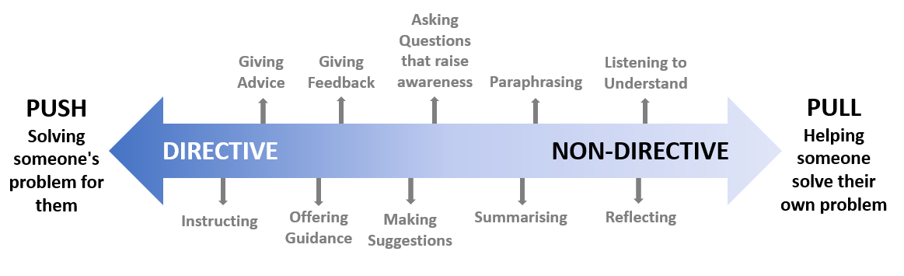

Adapted from [Directive and non-directive roles for personal tutors | Staff | Imperial College London](https://www.imperial.ac.uk/personal-tutors-guide/developing-students/coaching/directive-and-non-directive-roles-for-personal-tutors/)

Directive communication involves telling, instructing, or suggesting what the supervisee should do, think, or feel. They are based on the supervisor's expertise, experience, or perspective, and they aim to provide clarity, direction, or correction to the Supervisee

Non-directive communication approach involves asking, listening, or reflecting on what the supervisee says, thinks, or feels. They are based on the supervisee’s own resources, potential, or goals, and they aim to facilitate learning, awareness, or empowerment for the supervisee.

**When to use directive communication techniques?**

Directive communication techniques can be useful when the supervisee needs specific information, guidance, or feedback that the supervisor can provide. For example, if the supervisee is facing a development issue and the supervisor has the expertise and experience, the supervisor can use the directive technique to share knowledge and give advice or recommendations. A directive approach can also be useful when a supervisee feels stuck, confused, or overwhelmed and needs direction, structure, or support from the supervisor.

**When to use non-directive communication techniques?**

Nondirective communication techniques can be useful when the supervisee has the necessary information, skills, or resources to solve their own problems but needs some guidance, encouragement, or challenge from the supervisor. For example if the supervisee is facing a values or a motivational conflict the supervisor does not have the authority or expertise to resolve. The supervisor can use non -directive techniques to ask powerful questions, listen actively or reflect what they hear. Nondirective communication techniques can also be beneficial in situations where the supervisee wants to explore, learn or grow.

**The Power of Reflection: Supporting a non-directive approach**

The **GROW** Model is a coaching framework that fits well within a supervisory conversation, unlocking potential and possibilities of the supervisee. The GROW model was created by Sir John Whitmore in the late 1980s and has become the world's most used model for problem-solving, goal setting, and performance improvement.

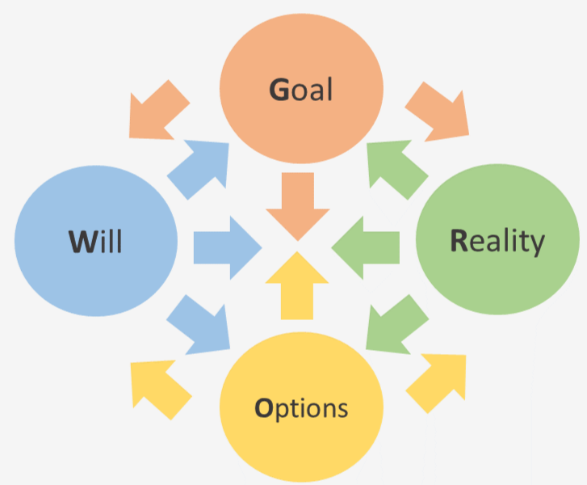

Adapted from the GROW Model - Whitmore, Sir J. (2019) Coaching for Performance. London, Brealey.

**What is the GROW model:**

|  |  |  |
| --- | --- | --- |
| **G** | **Goal** | **The goal is the end point, where does the supervisee want to be. The goal needs to be defined and clear to the supervisee when they have achieved this.** |
| **R** | **Reality** | **Where is the supervisee now? What are the issue, challenges, how far away are they from their goal?** |
| **O** | **Option** | **What are your options is progress and make this happen.** |
| **W** | **Way Forward** | **Options now need to be converted into actions that will take your supervisee to their goal. The ‘W’ of the GROW can also include When, by Whom and Will.** |

**What is the GROW model: Goal**

**Goal**

The goal is the end point, where does the supervisee want to be. The goal needs to be defined and clear to the supervisee when they have achieved this.

**Examples of questions for this stage:**

* What would you like to discuss today?
* What would be a successful outcome to your supervision today?
* What do you want to achieve today?
* What issues do you want to work on today?
* What outcome are you looking for?
* What will success look like?
* How important is this for you?
* How will things be different when you achieve your goal?

**Reality**

Where is the supervisee now? What are the issue, challenges, how far away are they from their goal?

**Example questions for this stage:**

* What is happening now?
* How do you feel about the situation?
* Are there any other relevant factors?
* Tell me more?
* What obstacles are there?
* Who else is involved?
* In an ideal world , what would be happening around this issue?
* On a scale of 1-10 how important/urgent/serious is the situation?

**Option**

What are your options - progress and make this happen.

**Example questions for this stage:**

* What could you do?
* What have you tires already?
* What options do you have?
* What options are most realistic?
* What could be done to change the situation?
* Who can support or help you?
* How committed are you to each alternative – rank 1-10.

**Way forward**

Options now need to be converted into actions that will take your supervisee to their goal. The ‘W’ of the GROW can also include When, by Whom and Will.

**Example questions for this stage:**

* What are the steps you need to take?
* How will you deal with your obstacles?
* How will you meet your goal?
* How will you measure the outcome?
* Who will you involve in this?
* On a scale of 1-10 how willing/excited are you in carrying out your goal?
* What does success look like?

Adapted from the GROW Model - Whitmore, Sir J. (2019) Coaching for Performance. London, Brealey.

**Further useful questions and advice:**

* What would you like to achieve from your supervision today?
* What did you notice about your performance?
* What was your experience of that?
* What is happening at the moment?
* What have you done so far?
* Would you like to tell me where you are with this?

​​​​​​Even if a neutral question is asked you supervisee may answer by describing what went wrong it is important that the supervisee also recognises their strengths not just their weaknesses.

* What went well?
* What challenged you?
* What are your strengths?
* What are you enjoying about this?
* What difficulties are you experiencing?
* What have you achieved so far?

Sometimes your supervisee will talk about why the failures were someone else’s fault. By making the questions more personal:

* What was your contribution to the success/failure of the project?
* What might you personally have done differently that could have produced a different result

**Positive Feedback**

You may find your supervisee dwells on something that did not go so well, ignoring what did go well.

This is an opportunity to give positive feedback on what your supervisee has done well.

* May I tell you what I liked?
* It sounds like you have made real headway there
* I’ve notice a new confidence in you recently.
* If you could do it again, what would you do differently?
* Where would you like to be?

**Dream it!** By placing the supervisee in the future will help with raise their energy, motivation and confidence.

* Imagine you have achieved it – what do you see/feel/hear
* What are the benefits?

**Open and Closed Questions**

**Open questions**

Open questions are questions that don’t restrict the answer supervisees in the answers they provide. Open questions support Supervisee’s in elaborating on their thoughts.

An open question always starts with

* What?
* How?
* Where?
* When?

Be cautious when using 'why' as this can at times appear judgemental.

**Closed Questions**

A closed question is a type of question that typically requires a short, specific answer, often a yes or no response. It limits the supervisee’s ability to provide detailed or open ended information. Closed questions are useful for gathering specific information or confirming facts.

Examples of closed questions :

* Do you consider yourself to be a goal – orientated person?
* What shape best represents your personality?
* Are you allergic to any specific foods?
* How many hours of sleep do you get on an average night?
* Do you consider yourself more or less stressed than the average person?

**References:**

* Whitmore, Sir J. (2019) Coaching for Performance. London, Brealey.
* [Directive and non-directive roles for personal tutors | Staff | Imperial College London](https://www.imperial.ac.uk/personal-tutors-guide/developing-students/coaching/directive-and-non-directive-roles-for-personal-tutors/)

# **Module 7 -** [**The Role of Power Dynamics in Supervision**](https://oneworkforcesussex.com/mod/hvp/view.php?id=394)

**The Role of Power Dynamics in Supervision (Video Transcript)**

*Power dynamics are inherent due to the hierarchical structure of supervision. Often you as a supervisor will have more years of training and experience when compared to your supervisee; this can often be seen as a power imbalance (Bernard & Goodyear 2014).*

*Supervisee’s will respond differently to imbalance - from seeing your expertise as advantageous to their supervision (De Stefano, Hutman, & Gazzola, 2017) while others may feel in a vulnerable position. Nonetheless, failure to adequately attend to power issues in supervision can result in ineffective or even harmful supervision (Cooke, 2018).*

*On the next page we encourage you to think about your own experiences of power dynamics within your supervision? What did this look like, what did it feel like?*

Cook, R. M., McKibben, W. B., & Wind, S. A. (2018). Supervisee perception of power in clinical supervision: The Power Dynamics in Supervision Scale. Training and Education in Professional Psychology, 12(3), 188–195. [https://doi.org/10.1037/tep0000201](https://psycnet.apa.org/doi/10.1037/tep0000201)

**Reflective Question: Have you experienced power dynamics within your supervision? What did this look like, what did it feel like?** *Try to think about both positive and negative experiences, and how this power dynamic impacted the supervision.*

|  |
| --- |
| *Use this space to write your answer.* |

**Ways to Normalise Power Dynamics**

Supervisee’s are often aware of power dynamics within their supervision but can be hesitant to share concerns due to fears of negative implications *(Ladany et al 1996*).  
  
The supervisor takes the lead in initiating these discussions and naming specific aspects of power directly (*Mangione et al., 2011)*. A **Power Dynamic in Supervision Scale**(PDSS) can help to normalize power dynamics that may otherwise be difficult to discuss (*Cook et al 2018).*

On the next page is the PDSS scale. Review the scale and use it to rate your own experience of a recent supervision.

(You can download a copy of the full article by *Stefanie A. Wind, Ryan M. Cook & W. Bradley McKibben* through the 'Resources / Downloads' section of the course, or by clicking the link below: [**Supervisees’ of differing genders and races perceptions of power in supervision (PDF Download)**](https://oneworkforcesussex.com/pluginfile.php/2334/mod_resource/content/1/Supervisees%E2%80%99%20of%20differing%20genders%20and%20races%20perceptions%20of%20power%20in%20supervision.pdf))

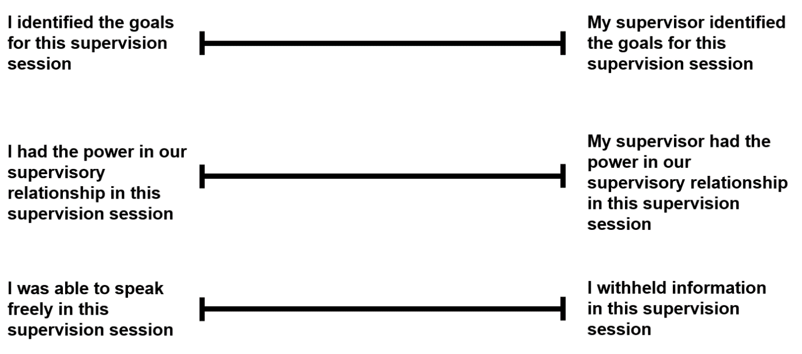

The Power Dynamics in Supervision Scale (PDSS) Cook et al 2018

The PDSS is scored 1 to 4, and all not applicable responses are treated as missing data in the analysis (scored as 0).

**Sample stems include:**  
(a) *“I identified the goals for this supervision session”*(supervisee power) to “*My supervisor identified the goals for this supervision session*” (supervisor power), and

(b) *“I trust my supervisor to keep what was discussed in this supervision session confidential*” (supervisee power) to *“I do not trust my supervisor to keep what was discussed in this supervision session confidential”*(supervisor power).

(Download a copy of The Power Dynamics in Supervision Scale (PDSS) Cook et al 2018 here: [**The Power Dynamics in Supervision Scale (PDSS) Cook et al PowerPoint download**](https://oneworkforcesussex.com/mod/resource/view.php?id=426))

**Acknowledging Power Dynamics**

Acknowledging power dynamics within a relationship helps maintain healthy boundaries and supports the empowerment and autonomy of the supervisee*(Szymanski 2003, Bernard & Goodyear 2014).*

**Tips to support your supervision:**

* Encourage your supervisee to focus on areas where they feel empowered as this helps develop their autonomy.
* Ask your supervisee open questions to better understand the factors that facilitate or inhibit aspects of clinical supervision.
* Support the capacity of your supervises to think, reflect and develop their own solutions.
* Guide your supervisee to recognize the impact of emotions of self when working with complexity.

**A Transcultural Exercise to Promote Culturally Sensitive and Responsive Supervision**

*Hawkins and Shohet (2012)*describe an exercise, shown on the next page, to encourage supervisors and supervisees to become conscious of the impact of culture and power within their supervisory relationship. It is intended to help reflection on what is central in terms of culture, influences on views, values and beliefs and in turn habitual ways of thinking that may arise from cultural assumptions. Culture is considered in its widest sense, including aspects such as race, ethnicity and gender as well as those less commonly discussed such as socioeconomic status, place in family or educational background, amongst others.

**Exercise:**

**(1)** Person A explains to Person B about their culture. Culture is interpreted as any aspects of a person’s life that they think are relevant.  
**(2)**After listening carefully, Person B recounts what has been heard.  
**(3)** Person A clarifies any misunderstandings and can add further information.  
**(4)** Person B then shares and reflect how this will relate to supervision and the supervisory relationship.  
**(5)** The roles are reversed whereby Person B shares their culture with Person A and the above steps are repeated.  
**(6)** Finally, differences and similarities between cultures are considered and discussed and the impact on the supervisory relationship, supervision and practice.

* *Hawkins, P., & Shohet, R. (2012). Supervision in the helping professions (4th ed.). Open University Press.*
* *Anita Soni, Haley Fong & Tara Janda (2022) An exploration of two supervisors’ engagement in a transcultural supervision exercise to support culturally responsive supervision with trainee educational psychologists (TEPs), Educational Psychology in Practice.*

**Reflective Question: How do you think this exercise could reveal a power dynamic?**

|  |
| --- |
| *Use this space to write your answer.* |

**Reflective Question: Have you ever felt that your own culture has been misunderstood by a peer? Describe how this felt.**

|  |
| --- |
| *Use this space to write your answer.* |

**Further Reading on Power Dynamics**

Links to further reading about power dynamics as it relates to supervision:

* **Social Power in Supervision**- Daphne Hewson (2016) - [**PDF Download Link**](https://oneworkforcesussex.com/mod/resource/view.php?id=396)
* **Supervisees’ of differing genders and races perceptions of power in supervision** - Stefanie A. Wind, Ryan M. Cook & W. Bradley McKibben - [**PDF Download Link**](https://oneworkforcesussex.com/pluginfile.php/2334/mod_resource/content/1/Supervisees%E2%80%99%20of%20differing%20genders%20and%20races%20perceptions%20of%20power%20in%20supervision.pdf)
* **An exploration of two supervisors’ engagement in a transcultural supervision exercise to support culturally responsive supervision with trainee educational psychologists (TEPs)**Anita Soni, Haley Fong & Tara Janda - [**PDF Download Link**](https://oneworkforcesussex.com/mod/resource/view.php?id=397)
* **Increasing supervisor savvy around culture, race, and identity Culturally responsive supervision -**Tori DeAngelis - [**Web Link**](https://www.apa.org/monitor/2023/01/culturally-responsive-supervision)

**References:**

* Edgar, D,E. Et al. 2021.  Clinical Supervision: A mechanism to support person-centred practice? An integrative review of the literature.  Journal of Clinical Nursing. 32 1935-1951
* Peters, H,C. Et al 2022. Integrated supervision framework: A multicultural, social justice and ecological approach.  Canadian Psychology. 64(4):511-522
* Hook, J. et al. 2016.  Cultural humility in Psychotherapy Supervision. American Journal of Psychotherapy. 70(2):149-166 (talks about different methods of teaching cultural sensitivity)
* Wallbank, S. The Restorative Resilience Model of Supervision.  A reader exploring resilience to workplace stress in health and social care professionals.  Pavilion Publishing.
* Ruch G (2007) Reflective Practice in Child Care Social Work: the Role of Containment. British Journal of Social Work. 37, 659-680.

# **Module 8 -** [**Trauma Informed Supervision**](https://oneworkforcesussex.com/mod/hvp/view.php?id=398)

The following video from NHS Education for Scotland provides a good grounding in the topic of trauma informed practice**: (Trigger warning: discussion of domestic abuse, sexual abuse)**

[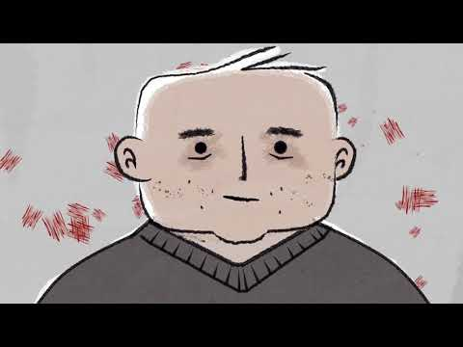](https://www.youtube.com/embed/zg8ahtHIRxU?feature=oembed)

<https://www.youtube.com/watch?v=zg8ahtHIRxU>

Credit: NHS Education for Scotland

**Reflective Question: What does the phrase trauma-informed mean to you?**

|  |
| --- |
| *Use this space to write your answer.* |

**Reflective Question: Thinking about what you’ve learned so far, why would this be relevant for supervision?**

|  |
| --- |
| *Use this space to write your answer.* |

**What is Trauma?**

Trauma results from an event, series of events, or set of circumstances that is experienced by an individual as harmful or life threatening. While unique to the individual, generally the experience of trauma can cause lasting adverse effects, limiting the ability to function and achieve mental, physical, social, emotional or spiritual well-being.

**Important Reminder***- A reminder that when we talk about being 'trauma informed', this does not relate to knowing or disclosing an individual’s specific trauma. During supervision, never ask or presume a supervisees trauma. There is no need for the person to disclose their trauma.*

**What is Trauma and Culturally sensitive supervision?**

There are 6 principles of trauma-informed practice:**safety, trust, choice, collaboration, empowerment,** and **cultural consideration**. It seeks to avoid re-traumatising the individual.

Trauma sensitive supervision, sometimes called trauma informed, is concerned with understanding how experience/s impact and influence the supervises attitudes, beliefs, identity and somatic responses.

Trauma sensitive supervision is the state of holding space for an individual to explore their responses and reactions to a situation which they have found traumatic and to refer on – it is not to treat the trauma response.  For those who have experienced trauma the supervision may be helpful to enable the use of curiosity to reimagine their shattered world, leading to post-traumatic growth.

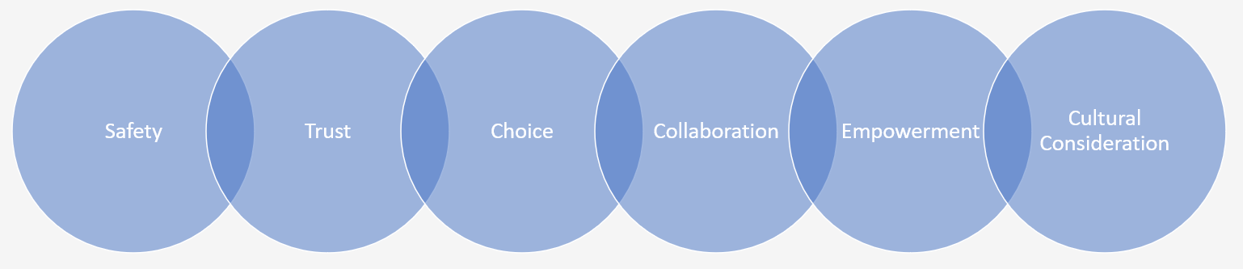

**Multicultural Supervision**

**Multicultural supervision** is concerned with understanding how social context, ecosystems and identities intersect and influence supervisory attitudes and beliefs, knowledge, skills and actions.

**Social justice supervision** extends beyond multiculturalism by efforts to ameliorate social, cultural, political, economic, historical and structural barriers related to power, oppression, inequity and colonisation.

**Ecological supervision** focuses on exploring how inter-related contextual factors and systems influence and shape individuals and their development.

Attending to these areas during supervision is essential for contemporary, ethical, effective and competency based clinical practice; particularly given long-established issues of discrimination, marginalisation, stigma, and inequity.   This approach can support the mental health of those impacted by such forms of oppression.

Additionally, this approach supports supervisors and supervisees to build their competence in working with diverse communities, leading to a more holistic, resilient and person-centred framework of support.

**Reflective Question: Why do you think it is important to consider multicultural supervision, social justice supervision and ecological supervision in your supervision practice?**

|  |
| --- |
| *Use this space to write your answer.* |

**Reflective Question: What problems could occur without a multicultural approach to supervision?**

|  |
| --- |
| *Use this space to write your answer.* |

**How can we provide trauma sensitive supervision?**

**Realise that trauma can affect individuals, groups and communities**

Trauma-sensitive practice is an approach to health and care interventions which is grounded in the understanding that trauma exposure can impact an individual’s neurological, biological, psychological and social development.

**Recognise the signs, symptoms and widespread impact of trauma**

Trauma-sensitive practice aims to increase practitioners’ awareness of how trauma can negatively impact on individuals and communities, and their ability to feel safe or develop trusting relationships.

It aims to provide supervision sessions which are accessible and safe by creating culturally sensitive, safe spaces that people trust and want to use. It seeks to prepare practitioners to work in collaboration and partnership with people and empower them to make choices about their health and wellbeing.

Trauma-sensitive practice acknowledges the need to see beyond an individual’s presenting behaviours and to ask, ‘*What does this person need?’* rather than ‘*What is wrong with this person?’.*

**Preventing re-traumatisation**

It seeks to avoid re-traumatisation which is the re-experiencing of thoughts, feelings or sensations experienced at the time of a traumatic event or circumstance in a person’s past. Re-traumatisation is generally triggered by reminders of previous trauma which may or may not be potentially traumatic in themselves.

The purpose of trauma-sensitive supervision is not to treat trauma-related difficulties, which is the role of trauma-specialist services and practitioners. Instead, it seeks to address the barriers that people affected by trauma can experience.

On the next few pages, we have broken down the principles of trauma-informed practice:

**Safety**

The physical, psychological and emotional safety of supervisees is prioritised, by:

* people knowing they are safe or asking what they need to feel safe
* there being reasonable freedom from threat or harm
* attempting to prevent re-traumatisation
* putting policies, practices, and safeguarding arrangements in place

**Trustworthiness**

Transparency exists in an organisation’s policies and procedures, with the objective of building trust among staff, service users and the wider community, by:

* the organisation and staff explaining what they are doing and why
* the organisation and staff doing what they say they will do
* expectations being made clear and the organisation and staff not overpromising

**Choice**

Supervisors and supervisees are supported in shared decision-making, choice and goal setting to determine the plan of action they need to move forward, by:

* ensuring supervisees have a voice in the decision-making process
* listening to the needs and wishes of supervisees
* explaining choices clearly and transparently
* acknowledging that people who have experienced or are experiencing trauma may feel a lack of safety or control over the course of their life which can cause difficulties in developing trusting relationships

**Collaboration**

The value of staff and service user experience is recognised in overcoming challenges and improving the system as a whole, by:

* using formal and informal peer support and mutual self-help
* the supervisor asking the supervisee what they need and collaboratively considering how these needs can be met
* focusing on working alongside and actively involving the supervisee in addressing their challenges

**Empowerment**

Efforts are made to share power and give staff a strong voice in decision-making, at both individual and organisational level, by:

* validating feelings and concerns of supervisees
* listening to a person's wants and needs
* supporting people to make decisions and take action
* acknowledging that people who have experienced or are experiencing trauma may feel powerless to control what happens to them, isolated by their experiences and have feelings of low self-worth

**Cultural consideration**

Move past cultural stereotypes and biases based on, for example, gender, sexual orientation, age, religion, disability, geography, race or ethnicity by:

* offering access to gender responsive services
* leveraging the healing value of traditional cultural connections
* incorporating policies, protocols and processes that are responsive to the needs of individuals served

**References:**

* Office for Health Improvement & Disparities - **Working definition of trauma-informed practice**- [**Web Link**](https://www.gov.uk/government/publications/working-definition-of-trauma-informed-practice/working-definition-of-trauma-informed-practice#:~:text=There%20are%206%20principles%20of,collaboration%2C%20empowerment%20and%20cultural%20consideration)

# **Module 9 -** [**Choosing the Right Model of Supervision for you**](https://oneworkforcesussex.com/mod/hvp/view.php?id=425)

In this module we will explore 4 different models for supervision. You may already have a framework which you find works well for you, and for this reason we recommend you pick and choose to study only the models which interest you.

We will discuss in the conclusion of this module how it can be beneficial to utilise more than one model for supervision.

The 4 different models of supervision we will explore in this module are:

* **Sonya Wallbank's Model of Restorative Supervision**
* **Resilience Based Clinical Supervision (RBCS)**
* **Seven-eyed Model (Peter Hawkins and Robin Shoet)**
* **Proctor’s Interactive Framework of Clinical Supervision**

**Sonya Wallbank's Model of Restorative Supervision**

Sonya Wallbank's model of restorative supervision is an evidence-based model designed to support the needs of professionals working with clinically complex roles that demand clear thinking and the ability to process information quickly and accurately to make decisions.

The model recognises when staff undertake their work that they can move between anxiety, fear, or stress and if they can process natural feelings about their work, this releases them to focus on their own learning needs and development, entering a creative, energetic and solution focused zone (Wallbank 2007).

This model of restorative supervision consists of several stages that aims to facilitate reflection, learning, and growth within a supervision relationship. Throughout the Zone Process Model, the supervisor actively facilitates reflection, offers guidance, and provides appropriate support. This model encourages deep exploration of the supervisee’s practice, promotes self-awareness, and fosters a continuous learning mindset.

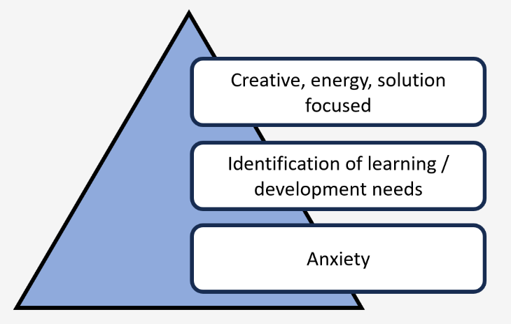

This model comprises several stages however the stages provide a general framework; the actual implementation of restorative supervision may vary depending on the supervisee’s specific context, needs, and the supervisor’s expertise.

Throughout the restorative supervision process, a restorative and strengths-based approach is taken. The aim is not to blame or criticize but to encourage the supervisees to reflect, learn, and take responsibility for their practice. The restorative supervision model promotes personal and professional growth, accountability, and a sense of resilience and well-being within the supervision relationship.

The stages are as follows:

The Zone Process Model, developed by Sonya Wallbank, is a framework that can be applied in clinical supervision to facilitate reflection, exploration, and learning. Here are the key steps involved in applying the Zone Process Model in Wallbank supervision:

**1. Establishing a Safe and Supportive Environment:** Like any supervision process, it is important to establish a safe space where the supervisee feels comfortable and supported. This includes setting clear expectations, maintaining confidentiality, and fostering trust between the supervisor and supervisee.

**2. Identifying the Zone:** The supervisee identifies a specific case, scenario or situation that they would like to explore further. This becomes the focal point of the supervision session and is referred to as "The Zone." The zone represents the area of practice that the supervisee wants to examine, understand, and learn from.

**3. Exploration and Description:** The supervisee describes the details of the zone, providing a comprehensive overview of the case or situation. This includes sharing background information, presenting relevant facts, and discussing any challenges or dilemmas encountered.

**4. Reflective Exploration:** In this stage, the supervisor guides the supervisee through a reflective exploration of the zone. The supervisor asks questions to help the supervisee gain deeper insights into their thoughts, feelings, and reactions related to the zone. This may involve exploring their assumptions, biases, values, and decision-making processes in relation to the zone.

**5. Analysis and Evaluation:** The supervisor and supervisee work collaboratively to analyze and evaluate the zone. This may include identifying strengths and limitations in the supervisee's practice, exploring alternative perspectives or interventions, and considering the potential impact on the client or organization.

**6. Learning and Integration:** Based on the analysis and evaluation, the supervisor and supervisee identify key lessons or learning points from the zone. This involves drawing on evidence-based practice, professional standards, and theoretical frameworks to support the integration of new knowledge and skills into the supervisee's practice.

**7. Action Planning:** The supervisor and supervisee develop an action plan based on the learning and insights gained from the zone. This plan includes specific goals, strategies, and steps that the supervisee will take to apply the new learning in their practice. The supervisor provides guidance and support to ensure the action plan is realistic, achievable, and aligned with the supervisee's professional development needs.

**Resilience Based Clinical Supervision**

Resilience based clinical supervision (RBCS) is underpinned by the principles of compassion-focused approach (Gilbert 2010). This is a form of clinical supervision focusing on the emotional systems motivating the response to a situation (Stacy et al 2017). A key aspect of RBCS is to recognise and make choices about the most beneficial mode of response to the impact of practice.

It is suggested that this approach helps the supervisee to develop an increased awareness of the importance of self-care helping them to positively manage the impact of work on themselves.

Resources for RBCS are housed on the Foundation of Nursing Studies Website: [Clinical Supervision Resources (fons.org)](https://www.fons.org/learning-zone/clinical-supervision-resources)

[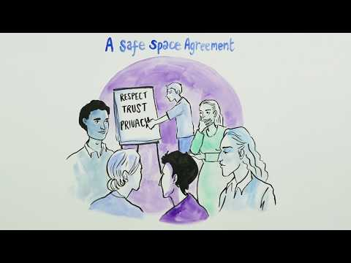](https://www.youtube.com/embed/YQsAS3co51U?feature=oembed)

Introduction Video: [Resilience Based Clinical Supervision | University of Nottingham | Creative Connection (youtube.com)](https://www.youtube.com/watch?v=YQsAS3co51U)

**Example of a Safe Space Agreement**

*"What conditions do you require to enable you to learn and feel supported in your group today?"*

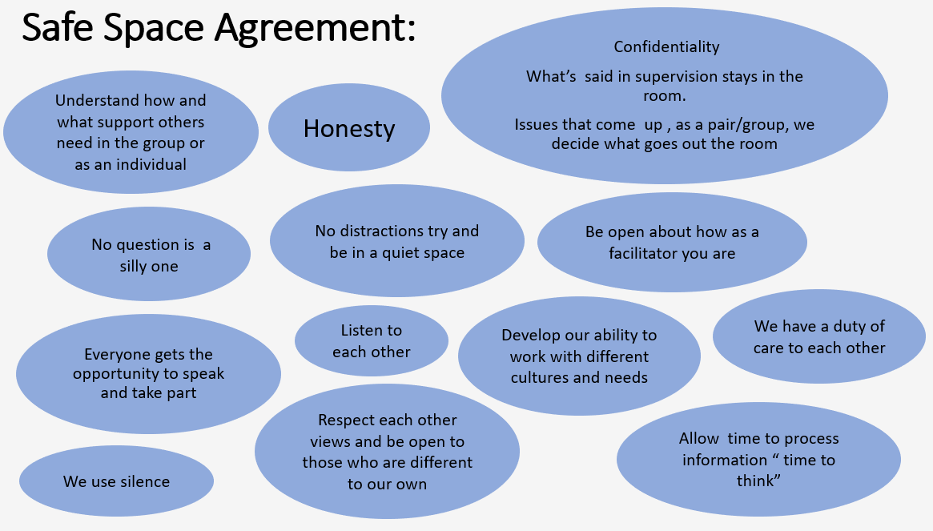

**Seven-eyed Model of Supervision - Peter Hawkins and Robin Shoet**

The Seven-Eyed Model is a model of clinical supervision developed by Peter Hawkins and Robin Shoet.

It provides a framework for supervisory conversations to explore and understand the dynamics of the supervisory relationship, the client's system, and the broader context in which the work takes place. The model metaphorically uses "eyes" to represent different perspectives or viewpoints.

On the next slide we will see an introductory video to the Seven-Eyed Model.

Reference: Hawkins, P., & Shohet, R. (2012). Supervision In The Helping Professions. 4th Edition. McGraw-Hill Education (UK).

The Seven-Eyed Model encourages supervisors and supervisees to move between these different perspectives to better understand the supervisee's practice, their interactions with clients, and the contextual influences. This holistic approach promotes reflective practice, self-awareness, and the ability to consider multiple dimensions of the supervisory process.

A brief explanation of the 7 modes is on the next page. For a more detailed overview of the Seven Eyed model you can watch the full playlist from Bob Cooke on YouTube: [Seven Eyed Model of Supervision - Full Playlist YouTube](https://www.youtube.com/playlist?list=PLD3GE-eEZ8mnHLUZ3AfM1wVvL577i7gN3)

**1. The Intra-Psychic Eye:** This eye focuses on the individual supervisee's internal world, including their thoughts, feelings, and inner experiences. It explores the impact of personal experiences, beliefs, and values on the supervisee's practice and interactions with clients.

**2. The Inter-Personal Eye:** This eye looks at the relationship between the supervisor and supervisee, particularly the dynamics, communication patterns, and power dynamics within their interactions. It examines the quality of the supervisory alliance, trust, and collaboration.

**3. The Relational Eye:** The relational eye expands beyond the supervisor-supervisee dyad and explores the supervisee's relationships with clients, colleagues, and other stakeholders. It considers the quality of these relationships, the impact of these interactions on the supervisee's practice, and the systemic influences at play.

**4. The Systemic Eye:** This eye focuses on the broader systemic context in which the supervisee operates. It examines the cultural, organizational, and social factors that influence the supervisee's work, including policies, structures, and power dynamics. This perspective helps to understand how the larger system impacts the supervisee's practice and the client's system.

**5. The Process Eye:** The process eye looks at the interactional patterns and sequences that unfold in the therapeutic or professional encounters. It examines how events unfold, the dynamics that emerge, and the impact of these processes on the client's system and the supervisee's practice.

**6. The Use of Self Eye:** This eye explores the supervisee's use of their own self in the therapeutic or professional encounter. It involves reflecting on the supervisee's awareness, presence, and skills in using themselves as tools for intervention. It considers the supervisee's self-awareness, empathy, and ability to attune to the client.

**7. The Transference/Countertransference Eye:** This eye examines the transference and countertransference dynamics in the therapeutic or professional relationship. It explores how both the supervisee and client project unconscious feelings, attitudes, and expectations onto each other. This perspective helps in understanding the impact of these dynamics on the therapeutic or professional process.

The Seven-Eyed Model encourages supervisors and supervisees to move between these different perspectives to better understand the supervisee's practice, their interactions with clients, and the contextual influences. This holistic approach promotes reflective practice, self-awareness, and the ability to consider multiple dimensions of the supervisory process.

**Proctor’s (1986) interactive framework of clinical supervision**

Proctor’s (1986) interactive framework of clinical supervision is one of the most commonly used in nursing practice and has three dimensions, what I view as the ‘how’, the ‘why’ and the ‘what’: »

**Restorative** is the ‘how’ clinical supervision is undertaken, adopting a non-judgemental approach with what we often refer to in mental healthcare as unconditional positive regard. »

**Formative** is the ‘why’ we need clinical supervision in practice, such as developing self-awareness through reflection and advancing our skills and knowledge through education and learning

**Normative** is the ‘what’ we do in practice – the managerial aspects that help us identify and follow processes that promote patient safety, underpinned by evidence-based expertise and critical reflection As intended by Proctor, the three aspects of clinical supervision are inter-related and allow supervisors to be flexible in their approach, depending on the needs of the supervisee. *(Jones ,Stephen."Let’s start treating clinical supervision like it’s an essential" Nursing Standard 38,no.3(2023):26-27doi:10.7748/ns.38.3.26.s13.)*

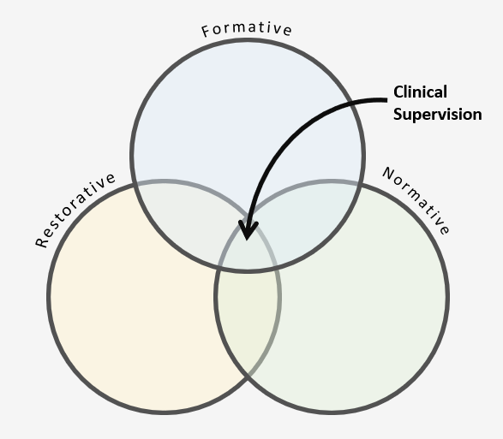

This model outlines four stages that supervisors and supervisees progress through during the supervision process. These stages are as follows:

**1. Stage 1: Pre-Interaction:** During this stage, the supervisor and supervisee establish a foundation for their supervisory relationship. They discuss goals, expectations, roles, and responsibilities. The supervisor provides orientation to the supervision process, clarifies boundaries, and establishes a supportive and collaborative environment.

**2. Stage 2: Beginning Supervision:** In this stage, the supervisor and supervisee engage in activities aimed at facilitating learning and development. The supervisee presents cases, discusses challenges, and sets goals for their professional growth. The supervisor provides guidance, feedback, and support to enhance the supervisee's clinical skills and knowledge.

**3. Stage 3: Middle Supervision:** This stage involves a more in-depth exploration of the supervisee's clinical skills, theoretical understanding, and personal development. The supervisor encourages self-reflection, critical thinking, and the application of theoretical concepts to real-world situations. The supervisee explores their strengths and weaknesses, reviews ongoing cases, and receives feedback on their practice.

**4. Stage 4: End of Supervision:** During the final stage, the emphasis shifts toward the termination of the supervision process. The supervisor and supervisee review progress made, evaluate learning outcomes, and consider future professional development needs. They may also discuss ongoing support mechanisms or recommendations for further growth beyond the supervisory relationship.

It is worth noting that while the Proctor's Model provides a structured framework for clinical supervision, its implementation can vary depending on the unique needs and context of the individuals involved. Flexibility in adapting the model to suit the specific requirements of the supervisor, supervisee, and clinical setting is essential.

Proctor’s 3 functional model:

* **Normative** - Focuses on managerial aspects to learning, including stat & mand training & CPD
* **Formative** - focus on developing knowledge & skills in professional development, using self reflection as a tool to develop self-awareness further, aiming to increase practitioners reflection of their practice.
* **Restorative** - personal development focusing on support, preventing burnout, and learning to manage stress.

**Delivery**

* 1:1 supervision
* Peer group supervision
* Combination of both types.

**Benefits** - When done well

* Considers different elements that comprise equal weight to ensure practitioners consider their own well-being and personal and professional development.
* Provides individuals with another avenue of feedback beyond the normal managerial feedback process.
* Offers the opportunity for individuals to identify skills to develop or focus on.

**What does this approach not offer?**

* Does not consider the importance of understanding why we react emotionally to a situation.
* Does not identify service improvement as crucial.

**Skills for success**

* Coaching approach
* Effective & Supportive feedback skills

**Useful resource for further learning:**

[Routledge Handbook of Clinical Supervision (routledgehandbooks.com)](https://www.taylorfrancis.com/routledge-handbooks/?context=rho)

**Conclusion - Why Use More Than 1 Model?**

The idea of having more than one model is seen as a benefit, acknowledging that different clinical and workplace situations may require slightly different considerations, therefore more models allow staff to use the most appropriate one for their specific needs *(Fowler, 1996).*

Proctor's Model of Clinical Supervision developed in 1986 which like other models encapsulates the original purpose of Clinical Supervision, is the most cited as used in practice, structured through three key areas. Normative: promoting and complying with policies and procedures, developing standards and contributing to clinical audit; Formative: developing skills and evidence-based practice; Restorative: enabling practitioners to better understand and manage the emotional burden of nursing practice *(White & Winstanley, 2009).*

**References:**

* Fowler, J. (1996). The organisation of clinical supervision within the nursing profession: A review of the literature. Journal of Advanced Nursing, 23(3), 471–478
* White, E., & Winstanley, J. (2009b). Implementation of Clinical Supervision: Educational preparation and subsequent diary accounts of the practicalities involved, from an Australian mental health nursing innovation. Journal of Psychiatric & Mental Health Nursing, 16(10), 895–903.
* Jones ,Stephen."*Let’s start treating clinical supervision like it’s an essential*" Nursing Standard 38,no.3(2023):26-27doi:10.7748/ns.38.3.26.s13.

# Module 10 - [**Knowing and Setting Our Boundaries as Supervisors**](https://oneworkforcesussex.com/mod/hvp/view.php?id=399)

Boundaries in any relationship are important to develop and establish trust and confidence with those you are working with. It helps those you are working with to know how to get the best from you and what to expect from you. Within a supervision relationship this is even more important. It provides guidance about what is considered appropriate and what is either beyond the scope of the session or should be discussed in a different arena or individual.

**Reflective Question: What are your intentions for being a supervisor? Be as honest as possible - what do you think you will be getting out of it?**

|  |
| --- |
| *Use this space to write your answer.* |

Things to think about when setting boundaries might include:

* **Time** - what is going to work for both of you. There is no point in arranging a session straight after another meeting as this can interfere with the quality of the session and your ability to be present.
* **Environment** – It should be free of distractions. This includes turning off phones and computers.
* **Number and frequency of sessions** – if you are starting a new supervision relationship it might be best to undertake a couple of sessions and then agree to have an open and honest discussion about how it's going. Agreeing this at the beginning sets the groundwork for either of you to decide if it's not the right fit.
* Have a list of resources available that you can refer someone to if you think they might need **additional support**. Creating this yourself can be a useful way to get to know the offers in your area, a suggested list is offered here.
* **Dual relationship** – you may know one another in a different role. It is important to acknowledge this and consider if there will be any conflict between them, an example could be a team leader and junior member of staff. The power imbalance may lead to either individual feeling unable to fully benefit from the session.
* **Out of session contact** – is this ok with you? If so, how would you like to be contacted, if not this needs to be clearly articulated.

**Reflective Question: How might power dynamics impact on your ability to set boundaries during supervision?**

|  |
| --- |
| *Use this space to write your answer.* |

**Reflective Question: Imagine that your supervisee comes to talk to you during your lunch hour - What would be your reaction?**

|  |
| --- |
| *Use this space to write your answer.* |

**Reflective Question: Can you think of any effective methods for setting Boundaries during supervision? (e.g. picking a suitable time and place)**

|  |
| --- |
| *Use this space to write your answer.* |

**Have you found any other successful methods for setting Boundaries during supervision?** Share them to the forum: [**Person-centred Supervision Forum - Q&A - Have you found any effective methods for setting boundaries during supervision? (oneworkforcesussex.com)**](https://oneworkforcesussex.com/mod/forum/discuss.php?d=34)

(Optional activity, login required)

**Why might someone push your boundaries?**

They might be experiencing moral injury.

**What is moral injury?**

Moral injury is understood to be the **strong cognitive and emotional response that can occur following events that violate a person's moral or ethical code.**

Potentially morally injurious events include a person's own or other people's acts of omission or commission, or betrayal by a trusted person in a high-stakes situation.

Unlike post-traumatic stress disorder, which can occur following threat-based trauma, potentially morally injurious events do not necessarily involve a threat to life. Rather, morally injurious events threaten one's deeply held beliefs and trust.

**For example:** health-care staff working during the COVID-19 pandemic might experience moral injury because they perceive that they received inadequate protective equipment, or when their workload is such that they deliver care of a standard that falls well below what they would usually consider to be good enough.

Moral injury is not considered a mental illness. However, an individual's experiences of potentially morally injurious events can cause profound feelings of shame and guilt, and alterations in cognitions and beliefs (e.g., “I am a failure”, “colleagues don't care about me”), as well as maladaptive coping responses (e.g., substance misuse, social withdrawal, or self-destructive acts).

It is these challenged beliefs and altered appraisals that are thought to lead to the development of mental health problems, with a 2018 meta-analysis finding that exposure to potentially morally injurious events was significantly associated with post-traumatic stress disorder, depression, and suicidality.

Reference:[Moral injury: the effect on mental health and implications for treatment - The Lancet Psychiatry](https://www.thelancet.com/journals/lanpsy/article/PIIS2215-0366(21)00113-9/fulltext#bib2)

**Moral Injury and Supervision**

In this instance the supervisee has experienced a disruption to their morals and values. Currently there is no validated treatment for moral injury; however international literature suggests it is an important public health concern.

Attention should be given to the emotional response of the individual and a referral to a mental health specialist may be required. **The focus of supervision should be on encouraging individuals to use self-forgiveness, acceptance, self-compassion, making amends.**  However, challenging the supervises perception of wrongdoing is unhelpful as it can disrupt their internal belief system further.

**Recognising Moral Injury:**

The language used by the supervisee may indicate feelings of shame and guilt.  Asking about these events should be done sensitively and with a non-judgmental approach otherwise the supervisee may be unwilling to discuss things again.  Active listening techniques such as paraphrasing alongside nods and gentle eye contact are all useful adjuncts to the session.

**What is burnout? *'A haemorrhaging of the self'***

Burnout is a state of physical and emotional exhaustion, (*Freudenberger 1974*). Often associated with long term workplace stress, the term has different meanings in international contexts (*Skovholt & Trotter-Mathison 2016*). If you are using the term, it is important to clarify with the other person what you mean by it.

**Maslach and Leiter (1997) defined burnout as:**

*“...the index of the dislocation between what people are and what they have to do.  It represents an erosion in values, dignity, spirit, and will – an erosion of the human soul.*” (Maslach & Leiter 1997:17)

**Common signs of burnout are:**

* Feeling helpless
* Tired
* Drained
* Trapped/defeated
* Cynicism
* Sense of detachment/feeling alone
* depersonalization
* Self-doubt

If left untreated burnout can lead to depression and anxiety. Extreme stress and pressure at work have been identified as antecedents, with women and young people more prone.

Burnout isn’t a suddenly occurring event, evidence suggests it is developmental (Kinman, Dovey & Teoh 2023). The number of stages varies depending on the work you read. However, as a guide early identification of anyone who is expressing or exhibiting signs of stress should initiate action. Within the supervisory relationship this will look different depending on the person. Having access to resources that you can signpost people to, such as stress risk assessments can be helpful as they provide someone with a tool to explain how they are feeling. An important element of wellness is recognizing and articulating our feelings to give them value.

**References:**

* Freudenberger, H. 1974. Staff burnout. Journal of social work. 30:159-165
* Kinman, G., A, Dovey & K, Teoh. 2023. Burnout in healthcare: Risk factors and solutions. London:The Society of Occupational Medicine.
* Maslach, C. & M, P, Leiter. 1997. The truth about burnout. San Francisco: Jossey-Bass.
* Skovholt, T, M. & M, Trotter-Mathison. 2016. The resilient practitioner. Burnout prevention and self-care strategies for counselors, therapists and health professionals. 3rd edition. London: Routledge

**What is stress?**

Visit this NHS webpage about 'Dealing with Stress'. Scroll to the bottom of the page and watch the video title: 'Video: Expert advice on dealing with stress'. While watching the video, think about your own strategies for managing stress, both helpful and unhelpful.

[Stress - Every Mind Matters - NHS (www.nhs.uk)](https://www.nhs.uk/every-mind-matters/mental-health-issues/stress/)

Take some time to reflect on this; and think about how you can support yourself as a supervisor.

# [**When in Doubt, Refer Out (Signposting)**](https://oneworkforcesussex.com/mod/hvp/view.php?id=424)

There may be situations where your supervisee requires support that you cannot provide. In cases like these, you may want to refer them to the following resources.

If you have additional resources to recommend, please add them to the forum: [When in Doubt, Refer Out (Signposting) - Forum Q&A](https://oneworkforcesussex.com/mod/forum/discuss.php?d=33)

**Mental Health Support**

**Apps:**

**Apps:**

* **Stay Alive** – [**Stay Alive App** - Grassroots Suicide Prevention (prevent-suicide.org.uk)](https://prevent-suicide.org.uk/find-help-now/stay-alive-app/?gclid=CjwKCAjwge2iBhBBEiwAfXDBR7GHTY26pKG2fbuCyE4H07ND9iE3P7deRSoNvz0jPZTXzodQKfro0BoCDYQQAvD_BwE)
* **Hub of Hope** - [**Mental Health Support Network**provided by Chasing the Stigma | Hub of hope](https://hubofhope.co.uk/)
* **Headspace for NHS -** Headspace is a science-based app in mindfulness and meditation, providing tools and resources to help reduce stress, build resilience, and aid better sleep. It is currently free for all NHS staff who sign up using their work email address. [**Headspace for NHS**](https://www.headspace.com/nhs)
* **Unmind for NHS -** Unmind is a mental health platform that empowers you to proactively improve your mental wellbeing, including digital programmes designed to help with stress, sleep, coping, connection, fulfilment and nutrition. It is free to access for NHS staff using the sign-up link provided. [**Create an account - Unmind**](https://nhs.unmind.com/signup)

**In person support**

* **Mental Health First Aider**– Contact Info available via your local intranet
* **Employee Assistance Programme**
* **Occupational Health Referral**(process requires HR and Manager involvement so not attractive at times)
* [**Sussex Recovery College**:](https://gbr01.safelinks.protection.outlook.com/?url=https%3A%2F%2Fwww.sussexrecoverycollege.org.uk%2F&data=05%7C02%7Calice.stewardson%40nhs.net%7Cbbf9b3b41e1c4a1a286608dc0b807c42%7C37c354b285b047f5b22207b48d774ee3%7C0%7C0%7C638397896409622370%7CUnknown%7CTWFpbGZsb3d8eyJWIjoiMC4wLjAwMDAiLCJQIjoiV2luMzIiLCJBTiI6Ik1haWwiLCJXVCI6Mn0%3D%7C3000%7C%7C%7C&sdata=UtW%2BvjwlN33ImVfZXhYubkokqnxcNDtGn2YDNyLrzQ0%3D&reserved=0) offers free in-person and online educational courses on mental health and recovery to help increase your knowledge and promote self-management, available to adults in Sussex.
* [**Southdown**](https://gbr01.safelinks.protection.outlook.com/?url=https%3A%2F%2Fwww.southdown.org%2Fhow-we-help%2Fservice-directory%2F&data=05%7C02%7Calice.stewardson%40nhs.net%7Cbbf9b3b41e1c4a1a286608dc0b807c42%7C37c354b285b047f5b22207b48d774ee3%7C0%7C0%7C638397896409622370%7CUnknown%7CTWFpbGZsb3d8eyJWIjoiMC4wLjAwMDAiLCJQIjoiV2luMzIiLCJBTiI6Ik1haWwiLCJXVCI6Mn0%3D%7C3000%7C%7C%7C&sdata=CpJtsWWGvgKH63ovNN2PCYMD0ZUHsneBORsgZ2Gnwug%3D&reserved=0): directory of Southdown services, who offer social prescribing, housing support, and out-of-hours mental health crisis prevention support for people in Sussex
* [**Health in Mind referrals**:](https://gbr01.safelinks.protection.outlook.com/?url=https%3A%2F%2Fwww.healthinmind.org.uk%2Freferral&data=05%7C02%7Calice.stewardson%40nhs.net%7Cbbf9b3b41e1c4a1a286608dc0b807c42%7C37c354b285b047f5b22207b48d774ee3%7C0%7C0%7C638397896409622370%7CUnknown%7CTWFpbGZsb3d8eyJWIjoiMC4wLjAwMDAiLCJQIjoiV2luMzIiLCJBTiI6Ik1haWwiLCJXVCI6Mn0%3D%7C3000%7C%7C%7C&sdata=7ZVYFY07f3w4JeGOg%2FJfyt6Rq3A5xBC9EuAhTDmRmCA%3D&reserved=0) referral form for free mental health courses and talking therapies for adults living in East Sussex
* [**Brighton and Hove Wellbeing Service**](https://gbr01.safelinks.protection.outlook.com/?url=https%3A%2F%2Fwww.brightonandhovewellbeing.org%2Freferrals&data=05%7C02%7Calice.stewardson%40nhs.net%7Cbbf9b3b41e1c4a1a286608dc0b807c42%7C37c354b285b047f5b22207b48d774ee3%7C0%7C0%7C638397896409622370%7CUnknown%7CTWFpbGZsb3d8eyJWIjoiMC4wLjAwMDAiLCJQIjoiV2luMzIiLCJBTiI6Ik1haWwiLCJXVCI6Mn0%3D%7C3000%7C%7C%7C&sdata=O8fO6pXwIwTf78%2FKdAdh5kUY1E7zhYBLXHMriiNVBdA%3D&reserved=0): referral form for free talking therapies for children and adults in Brighton and Hove
* [**IAPT (Improving Access to Psychological Therapies)**](http://www.sussexcommunity.nhs.uk/services/time-to-talk-talking-therapies-services-in-west-sussex/109066)services – Time to Talk – self referral NHS West Sussex Talking Therapies, for anxiety and depression.
* [**1Space**](https://gbr01.safelinks.protection.outlook.com/?url=https%3A%2F%2F1space.eastsussex.gov.uk%2F&data=05%7C02%7Calice.stewardson%40nhs.net%7Cbbf9b3b41e1c4a1a286608dc0b807c42%7C37c354b285b047f5b22207b48d774ee3%7C0%7C0%7C638397896409622370%7CUnknown%7CTWFpbGZsb3d8eyJWIjoiMC4wLjAwMDAiLCJQIjoiV2luMzIiLCJBTiI6Ik1haWwiLCJXVCI6Mn0%3D%7C3000%7C%7C%7C&sdata=mA6kc5M4TW6bXs1Z1M7luKWKnSH4kkz%2BvSUI9bNm8%2Bs%3D&reserved=0): helpful directory of support services available for people in East Sussex, including mental health support, accommodation support, and bereavement support.

**Financial Support**

* Citizens Advice - [Contact us about a Universal Credit application - Citizens Advice](https://www.citizensadvice.org.uk/benefits/universal-credit/claiming/helptoclaim/?gclid=CjwKCAjwge2iBhBBEiwAfXDBRwMBzVWbPAWHtYFkhSBPQyNuRMPpTTteS391otDaCDyGm5BrqrOlKxoCmDsQAvD_BwE)
* Unbiased - [Find 27,000 IFAs, Financial Advisers, Mortgage Brokers, Accountants & Bookkeepers (unbiased.co.uk)](https://www.unbiased.co.uk/?gclid=CjwKCAjwge2iBhBBEiwAfXDBR-1lO-w3keDka7bCerWWR8IOqR0iTIVY5BTLV5jsGC5iAGqEzzfYMBoCKI0QAvD_BwE)
* Employee Assistance Programme
* Union

**Legal Advice**

* Union
* Employee Assistance Programme
* Chichester Law Clinic (Free advice) - [Arun & Chichester Citizens Advice - Chichester Law Clinic (arunchichestercab.org.uk)](https://arunchichestercab.org.uk/contact-us/chichester-law-clinic/)
* University of Sussex – Free advice from Law students - [Free Legal Advice : Sussex Clinical Legal Education : Law Department : University of Sussex](https://www.sussex.ac.uk/law/clinical-legal-education/free-legal-advice)

# **Bringing it all Together**

**Preparation**

It is crucial that supervision delivery is underpinned with associated policies, procedures, and guidelines relevant to your place of work.

They should address:

* Purpose and meaning of supervision.
* How supervision contributes to organisational overall aims.
* Equality, diversity, and inclusion statement
* Supervision – whose responsibility, is it?
* Who is expected to participate in supervision?
* Organisational and professional expectations – Minimum requirements for attending supervision as suggested by organisational and professional bodies.
* Describe the models of supervision available.
* Training requirements for both supervisor and supervisee
* How records of supervision will be kept, stored, or used – refer to your local policy
* How supervision will be evaluated

**Confidentiality**

Sometimes, the supervisee will find supervision challenging because it requires sharing experiences that can, at times, lead to feelings of vulnerability.

To get the best out of supervision, it is essential to be able to trust that the feelings or experiences brought by the supervisee will be treated with respect and, importantly, confidentiality.

**Contracting**

Establishing a written agreement or contract between the supervisor and supervisee at the beginning of a supervision session is considered best practice.

A supervision contract is an agreement on how supervision will take place, including who is responsible for what. It should also acknowledge the organisation's expectations of supervision.

You may like to consider some of the following questions to support a contracting conversation with your supervisee.

* What is supervision?
* What are the benefits of supervision?
* What can I offer as a supervisor?
* What is my facilitation style?
* What experience, training, and qualifications do I have?
* What can supervisees expect to happen during supervision?

The contract's content is agreed upon by both the supervisee and supervisor. The term contract can sound very official and binding; as a supervisor, it may be helpful for you to describe it to your supervisee as a collaboration guideline.

The process of agreeing on a supervision contract provides an opportunity to establish the practical aspects of the supervision arrangement and share hopes and expectations.

For example of a contract, please refer to your organisation policy, procedures and guidelines:

**Please find an example below:**



**An example of a Group supervision contract**

The following is a list of ground rules or conditions of success for group supervision. The group should generate its own list, and all participants should discuss each point and agree upon each point. Below is an example of what is possible to include.

* Confidentiality
* Not to talk over or interrupt each other.
* Respect for our colleagues and differing opinions
* Listen to each other.
* Humour
* Encourage people to own their own experience
* Respectfully challenge
* Be aware of others, and try not to dominate the space.
* Look after ourselves and each other
* Take time out if you need to
* Keep to time

Establishing conditions for success can help participants feel safe to share their experiences while supporting the group function.

It can be helpful to display the conditions of success/ground rules as created by the group during the supervision session so that participants can stay mindful of what has been agreed.

Please also refer to resilience-based clinical supervision (RBCS) for further tips and tools to support group supervision.



**Record Keeping**

Maintaining supervision records is fundamental to demonstrating safe, ethical, and effective supervision practice. However, keeping records of supervision can be a sensitive and contentious issue. Please refer to your organisation's polices and procedures for further guidance.

Please consider…

* What is the purpose of documentation in supervision?
* What are the expectations regarding record keeping set out within your place of work?
* How does documentation support the process of supervision?
* Who owns the notes and records from supervision?
* Who has access to records of supervision?
* Where are the records stored, and how and for how long?

**An example of a record keeping sheet….**



**Example Supervision**

On the next page is an example supervision session – the video is annotated to show the steps going on in the background, it explains the thought process of both the supervisor and the supervisee.

We hope this helps to illustrate the various techniques and skills you have been learning throughout this course.

**Having watched the video, what were your reflections?**

* Do you think that this was a realistic portrayal of how supervision could work?
* Are there any elements from this that you could bring into you own practice?
* Did you identify any areas where this supervision could have been improved?

**Please share your reflections (and read the reflections of others) on the forum:** [**Bringing it all Together Forum**](https://oneworkforcesussex.com/mod/forum/discuss.php?d=50)