**Manager’s eLearning Workbook  
Managing Neurodiverse Teams**

GeniuswithinCIC

@geniuswithinCIC

Genius Within CIC



@GeniusWithinUK

© Genius Within 2024

Introduction

Welcome to the Manager’s eLearning Workbook.  This has been created to help you reflect on the learning from the five modules and consider how it is relevant to your role as Manager of a neurodiverse team.  Each module lasts for up to 15 minutes and can be paused, replayed or returned to at a later point.

The modules are:

1. How to have the conversation

2. Reasonable adjustments

3. Communication techniques and strategies

4. Performance management

5. How to create a neuro-inclusive workplace

At Genius Within we strive to empower people to be their best or to be working at their best. This means helping you to find a balance amongst:

* **Who you are**
* **What you want**
* **What you would like to have happen**

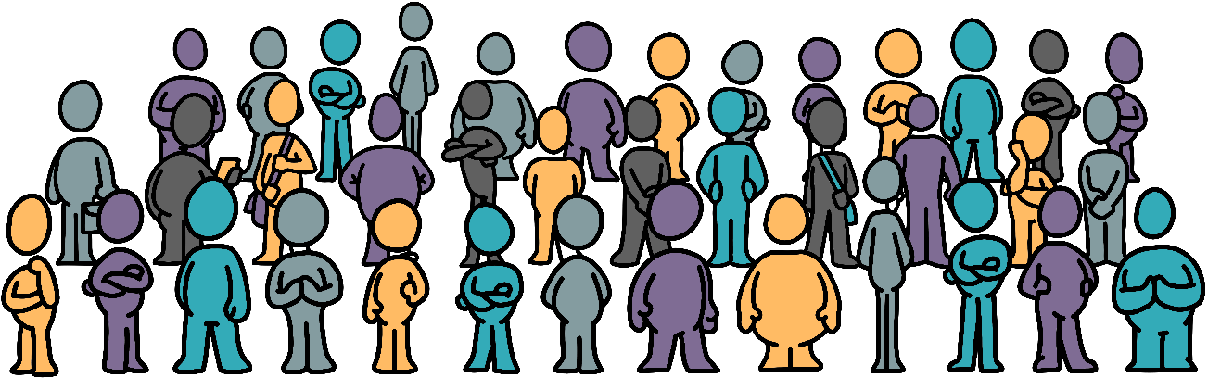

Module 1: How to have the conversation

* What is disclosure?
* Why can it be beneficial?
* What to do or say if someone discloses to you
* What to do after the conversation?

**What is disclosure?  
  
  
  
  
  
  
  
  
  
Why can it be so beneficial?**

What are the benefits of disclosure?

What is the law around disclosure?

What is your role when an employee discloses?

What is your role if you think an employee is neurodivergent?

If someone has disclosed to you:

Module 2: Reasonable adjustments

* What ‘reasonable adjustments’ are
* What typical reasonable adjustments are in the workplace for neurodivergent people
* What must be done as an employer or HR representative
* Where to get advice if you are not sure if a request is reasonable or not
* What services and training are available

What are reasonable adjustments?

Give examples of three reasonable adjustments

If an employee asks for reasonable adjustments, what do you as an employer /HR representative need to do?

Are there any reasonable adjustments that you need in the workplace?

Module 3. Communication Techniques and Strategies

* Understand how day-to-day communication is too ambitious for neurodivergent people
* Strategies for improving communication and sharing feedback

What is clean language?

How does clean language reduce misunderstandings?

Think about the last time you gave instructions to a team member. Were the instructions clean? If not, what could you have said/written instead?

Prepare some clean feedback for one of your team members:

|  |  |
| --- | --- |
| What worked well? |  |
| What didn’t work well? |  |
| What would work better? |  |

**Module 4: Performance Management**

* Understand what you need to have in place to manage the performance of neurodivergent people within your teams
* You will also have some information about the best way to go about managing performance, whether it’s good performance, poor, or overperformance

**Define effective performance management:**

**Over performance and under performance are both problems for neurodivergent staff.   
  
a) How would you manage over performance?**

**b) How would you manage under performance?**

**Before any formal performance management processes are put in place, what do you need to ensure has happened first?**

Module 5. How to Create a Neuro-inclusive Workplace

**This module will bring together learning from the previous four modules.**

**It will also explore three main principles:**

* Valuing diversity
* Building rapport
* Fostering psychological safety

**What does ‘valuing diversity’ mean to you?**

**Considering your team, what stage are they at: Forming, Storming, Norming or Performing?**

**What can you do to help them successfully move to the Performing stage if not already there?**

**Thinking about Karpman’s Drama Triangle:**

**a) Provide an example of when   
 the drama triangle has been  
 evident within your team.**

**b) What helped to resolve this? What could you have done to help resolve this more from drama to calmer?**

**What is Psychological Safety?**

**What can you do to help create Psychological Safety?**

**What are your next steps for having a neuroinclusive workplace?**

**What has been the most useful part of the Manager’s eLearning?**

**What is already working well in terms of managing your neurodiverse team?**

Our next level neurodiversity programme is designed to assess your organisation’s processes and identify where they can be flexed to provide the best working environment for all employees. The Next Level process supports the implementation of a more neurominority friendly ecosystem.

The GeniusFinder Pro is our new strengths-based assessment tool, which has been designed to support neurodivergent individuals and organisations explore the most common work-related strengths and struggles.

We will review the accessibility of your processes and systems for recruitment, onboarding, training, appraisals, performance management, promotion, and staff retention. Following the audit, we can make recommendations for change based on the principles of Universal Design, to remove any unconscious neurominority and disability bias.

As a Disability Confident Leader, Genius Within can also assist you in working towards your Disability Confident Employer status. This can enable you to draw from the widest possible pool of talent, improve staff engagement and retention, and lead the way for disability inclusion in the community.